# **Task 3:**

# **Set Up and Configure Cloud Storage Bucket**

1. Created bucket with unique name “elevate-lab-demo-bucket”

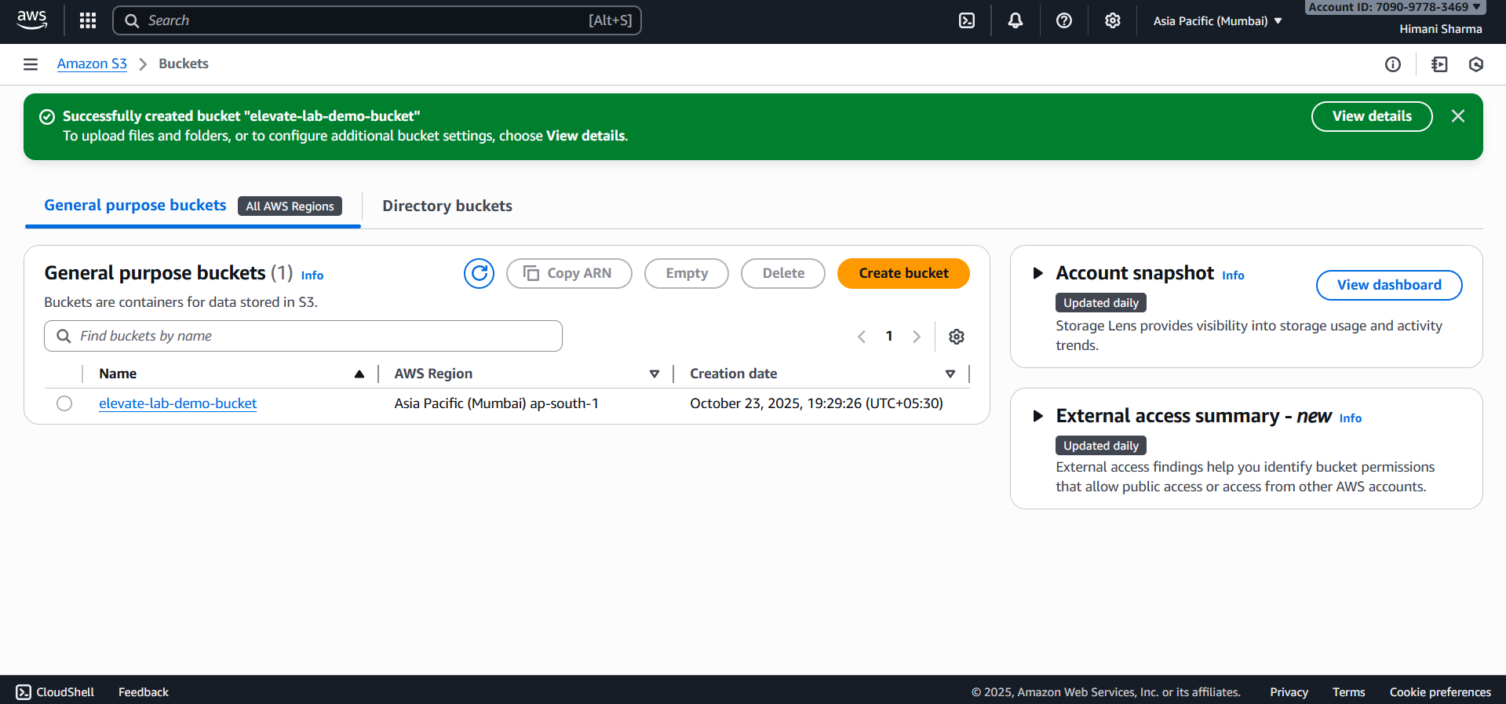

2. Selected “Asia Pacific (Mumbai)” region.

3. Uploaded png image in the created bucket:

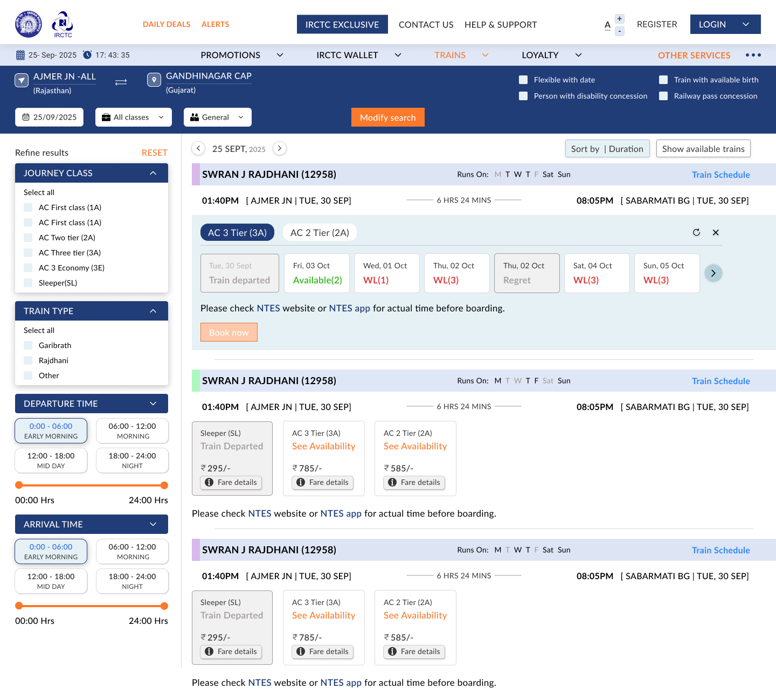

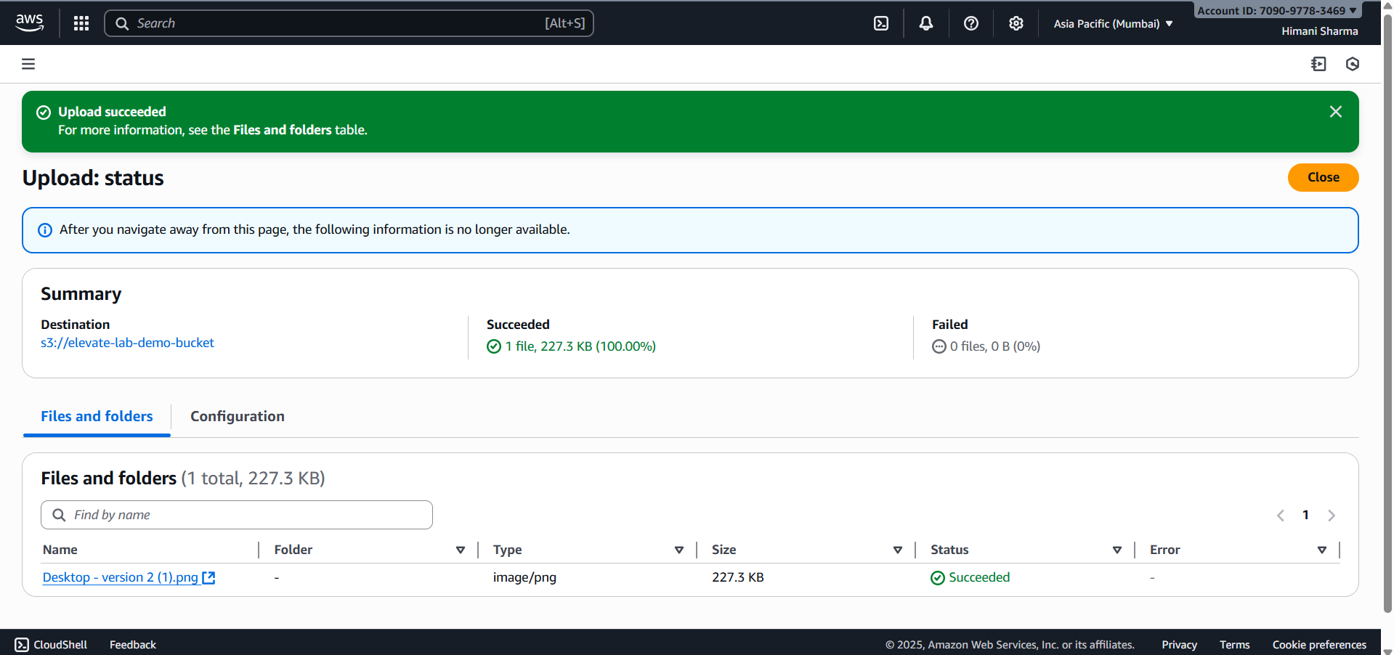

4. Enabled ACL and granted public access with read permissions:

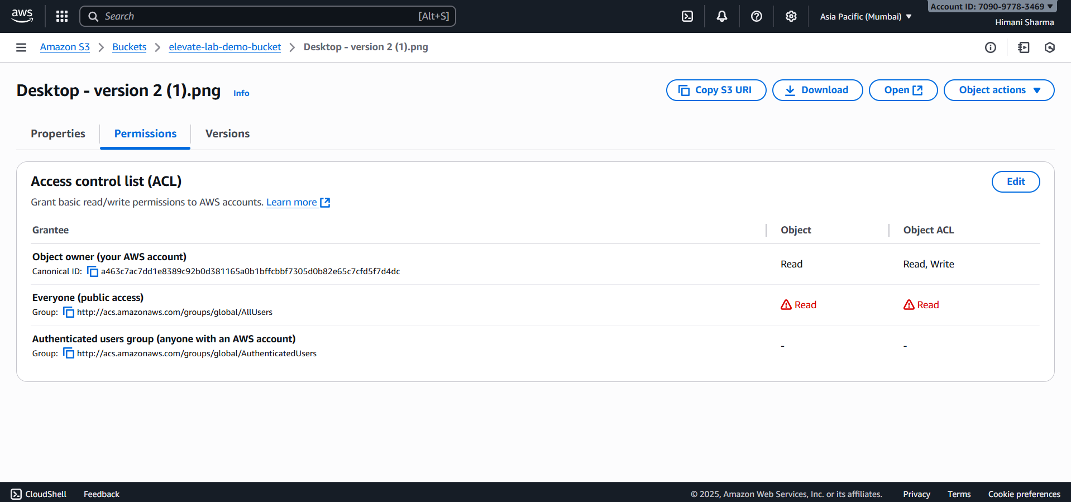

5. Following is the MetaData of the uploaded image in the bucket:

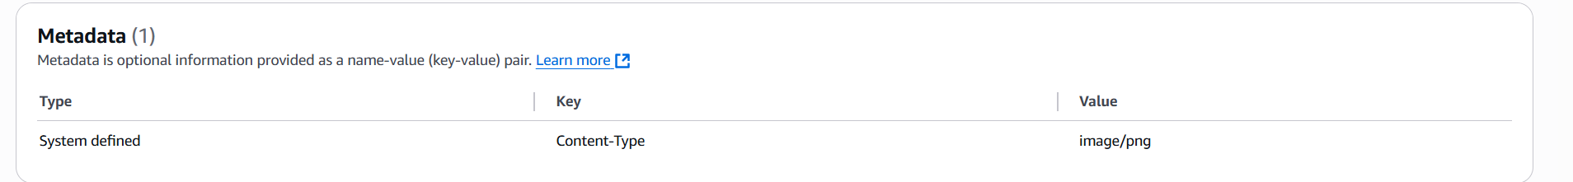

6. Object Url:

https://elevate-lab-demo-bucket.s3.ap-south-1.amazonaws.com/Desktop+-+version+2+(1).png

Use cases:

* Cloud storage is a service that lets people and companies store files like photos, videos, or documents securely on the internet instead of their computers.
* It allows easy access to files from anywhere, at any time, and on any device.
* It’s commonly used for data backups, file sharing, and storing website or app content.